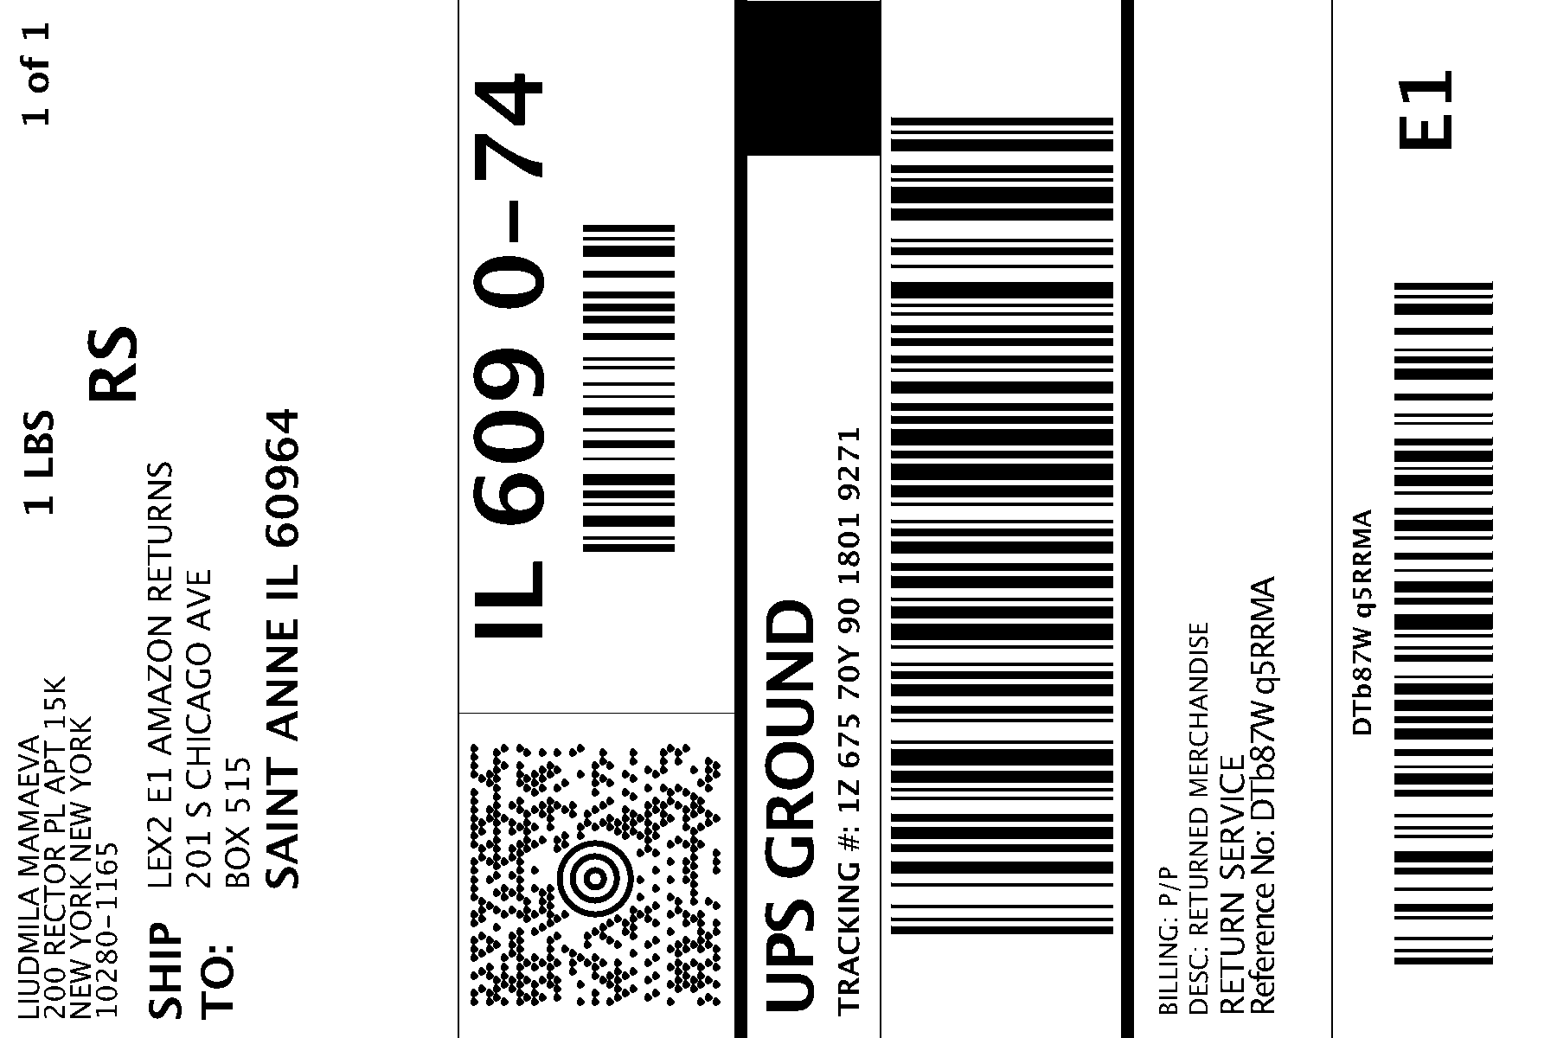

|  |  |
| --- | --- |
| **Item Descriptions** | **Quantity** |
| Razor V-17 Child Multi-Sport Helmet, Dino Gloss Green | 1 |

